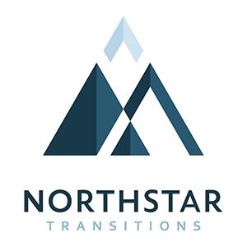
2595 Canyon Blvd, Ste 460
Boulder, Colorado 80302
Phone: 303.558.6400
Fax: 888.373.4385
www.northstartransitions.com

Residential Substance Abuse Therapist
Duties:
- Plan for and implement evidence-based skills and process groups
- Facilitate family and individual therapy sessions
- Perform bio-psycho-social clinical assessments
- Perform screens, not limited to: anxiety, depression, and suicide, for comprehensive assessment
- Supervise clients self-administer medication
- Maintain medication document as required by NorthStar Transitions.
- Coordinate care with other service providers and provide referrals
- Maintain client records and charts as required by NorthStar Transitions and the Office of Behavior Health
- Engage in professional development of mental health and substance abuse counseling, including evidence-based practices
- Attend weekly clinical and staff meetings weekly and group or individual supervision weekly
- Attend regular trainings related to agency and job responsibilities
- Provide individual supervision if appropriate
- Attend marketing events as needed

Minimum Qualifications:
- Licensure as LPC, LCSW or LMFT a must
- Licensure as a CAC II or LAC preferred
- EMDR &/or Trauma Training are Gold Star Candidates
- Know your way around computers and other technology
Core Competencies:
- Thorough knowledge of psychotherapy, substance abuse, and process disorders treatment modalities, not limited to: Dialectical Behavioral Therapy. Trauma Informed Care, Motivational Interviewing, 12 Step.
- Ability to facilitate experiential and somatic based interventions
- Knowledge of and ability to diagnose using DSM V and ASAM
- Knowledge of, or willingness to learn, OBH regulations for Substance Use Disorders treatment facilities and managed care requirements of insurance partners.
- Ability to perform clinical assessments and develop strengths-based, client centered treatment plans
- Excellent interpersonal skills, including ability to navigate conflict
- Good technical skills, including ability to navigate Microsoft Office, Electronic Health Record and google email systems
- Excellent organizational skills

Schedule & Salary:
- Two schedules are available: 8am-8pm 3 days/week at The Lodge facility near Ward, CO and 9am-7pm 4 days/week in Boulder.
- Salary dependent on experience & licensure

Send Resume to HR Director at: hr@nstprogram.com

